Sunday | Monday | Tuesday | Wednesday |  | Thursday | Friday | Saturday
 |  |  |  | 1 | 2 | 3 | 4
5 | 6  Labor Day  Rosh Hashanah Begins | 7 |  | 8 | 9 | 10 | 11
12  Grandparents Day | 13 | 14 |  | 15  Yom Kippur Begins | 16 | 17 | 18  Oktoberfest Begins
19 | 20  Sukkot Begins | 21 |  | 22  Autumn Begins | 23 | 24 | 25
26 | 27 | 28  Simchat Torah Begins |  | 29 | 30

    Lilac Calendar |  |  | 9:45 Hymn Sing  10:30 Dice Roll  1:45 Busy Hands  2:30 Reminisce  3:30 Hand Massage and Visits | 9:45 Music and Memories  10:30 Lawn Darts  1:45 Garden Picnic  3:00 One to One Visits  6:30 Tablebowling | 9:45 Exercise  10:30 Resident’s Council Meeting – M  10:30 Table Games  1:30 Mocktail with the Clements – M  3:15 Short Story Hour | 10:30 Saturday Morning Trivia  2:30 Sing Along DVD
9:45 Church Service with Gary Crosbie-M |  | 9:45 Beauty Boutique  10:30 Tuck Shop Cart  1:45 Prize Bingo  2:45 Sing Along DVD  3:45 Visits  5:45 Ring Toss | 9:45 iPad Fun  10:30 Catholic Mass – M  12:00 Level 1 BBQ  2:00 Active Games Afternoon  3:00 Short Story Time | 9:45 Hymn Sing  10:30 Darts  1:45 Ladies Tea  3:00 Hand Massages and One to One Visits  6:30 Snakes & Ladders | 9:45 Exercise  10:30 Jokes & Riddles  1:30 Mocktail with Dave Shakespeare – M  3:15 Horse Shoes | 9:30 Games Morning  1:30 Name that Tune  3:30 Short Stories
9:30 Sunday Hymn Sing  1:30 Shuffleboard  3:30 Sorting | 9:45 Exercise  10:30 Monday Morning Trivia  1:30 Bingo – M  3:15 Hand Massage and Visits | 9:45 Beauty Boutique  10:30 Tuck Shop Cart  1:45 Tablebowling  2:30 Sensory Stim  3:30 YouTube Fun  6:30 Hoops Game | 9:45 Hymn Sing  10:30 Ball Toss  1:45 Snakes & Ladders  2:30 Table Games  3:30 Visits | 9:45 Name that  Tune  10:30 Finish that Phrase  1:30 Birthday Party with Dave Shakespeare – M  3:15 Short Stories  5:45 Active Games | 9:45 Exercise  10:30 Old Time Tunes  1:30 Mocktail with Jack Coulson – M  3:15 Horse Races | 10:30 Saturday Morning Trivia  2:30 Big Bowling
10:30 Sunday Hymn Sing  2:30 Roll the Dice | 9:45 Exercise  10:30 Music & Movement  1:30 Food Committee Meeting – M  1:45 Ring Toss  2:30 Busy Hands  3:30 Short Stories | 9:45 Beauty Boutique  10:30 Tuck Shop Cart  1:45 Prize Bingo  2:45 Sing Along DVD  3:45 Visits  6:30 Lawn Darts | 9:45 iPad Fun  10:30 Catholic Mass – M  1:30 Welcome Fall with Jeff Dawdy – M  3:15 Active Game | 9:45 Hymn Sing  10:30 Big Bowling  1:45 Garden Picnic  3:00 Hand Massages and One to One Visits  5:45 Hoops Game | 9:45 Exercise  10:30 Board Games  1:45 Travelling Ice Cream Cart  3:30 iPad Games | 9:30 Games Morning  1:30 Name that Tune  3:30 Sorting Station
9:45 Church Service with Brian McKee – M  3:30 Ring Toss | 9:45 Exercise  10:30 Ball Toss & Music  1:30 Bingo – M  3:15 Hand Massages and Visits | 9:45 Beauty  Boutique  10:30 Tuck Shop Cart  1:45 Roll the Dice  2:30 Sensory Stim  3:30 Short Stories and Visits  5:45 Sing Along | 9:45 Hymn Sing  10:30 Hoops Game  1:45 Busy Hands  2:30 Reminisce  3:30 iPad Games and YouTube! | 9:45 Thursday Morning Trivia  10:30 i-Spy!  1:45 Sing Along DVD  2:30 Ring Toss  3:30 Visits  6:30 Tablebowling |   M = McMillen Hall
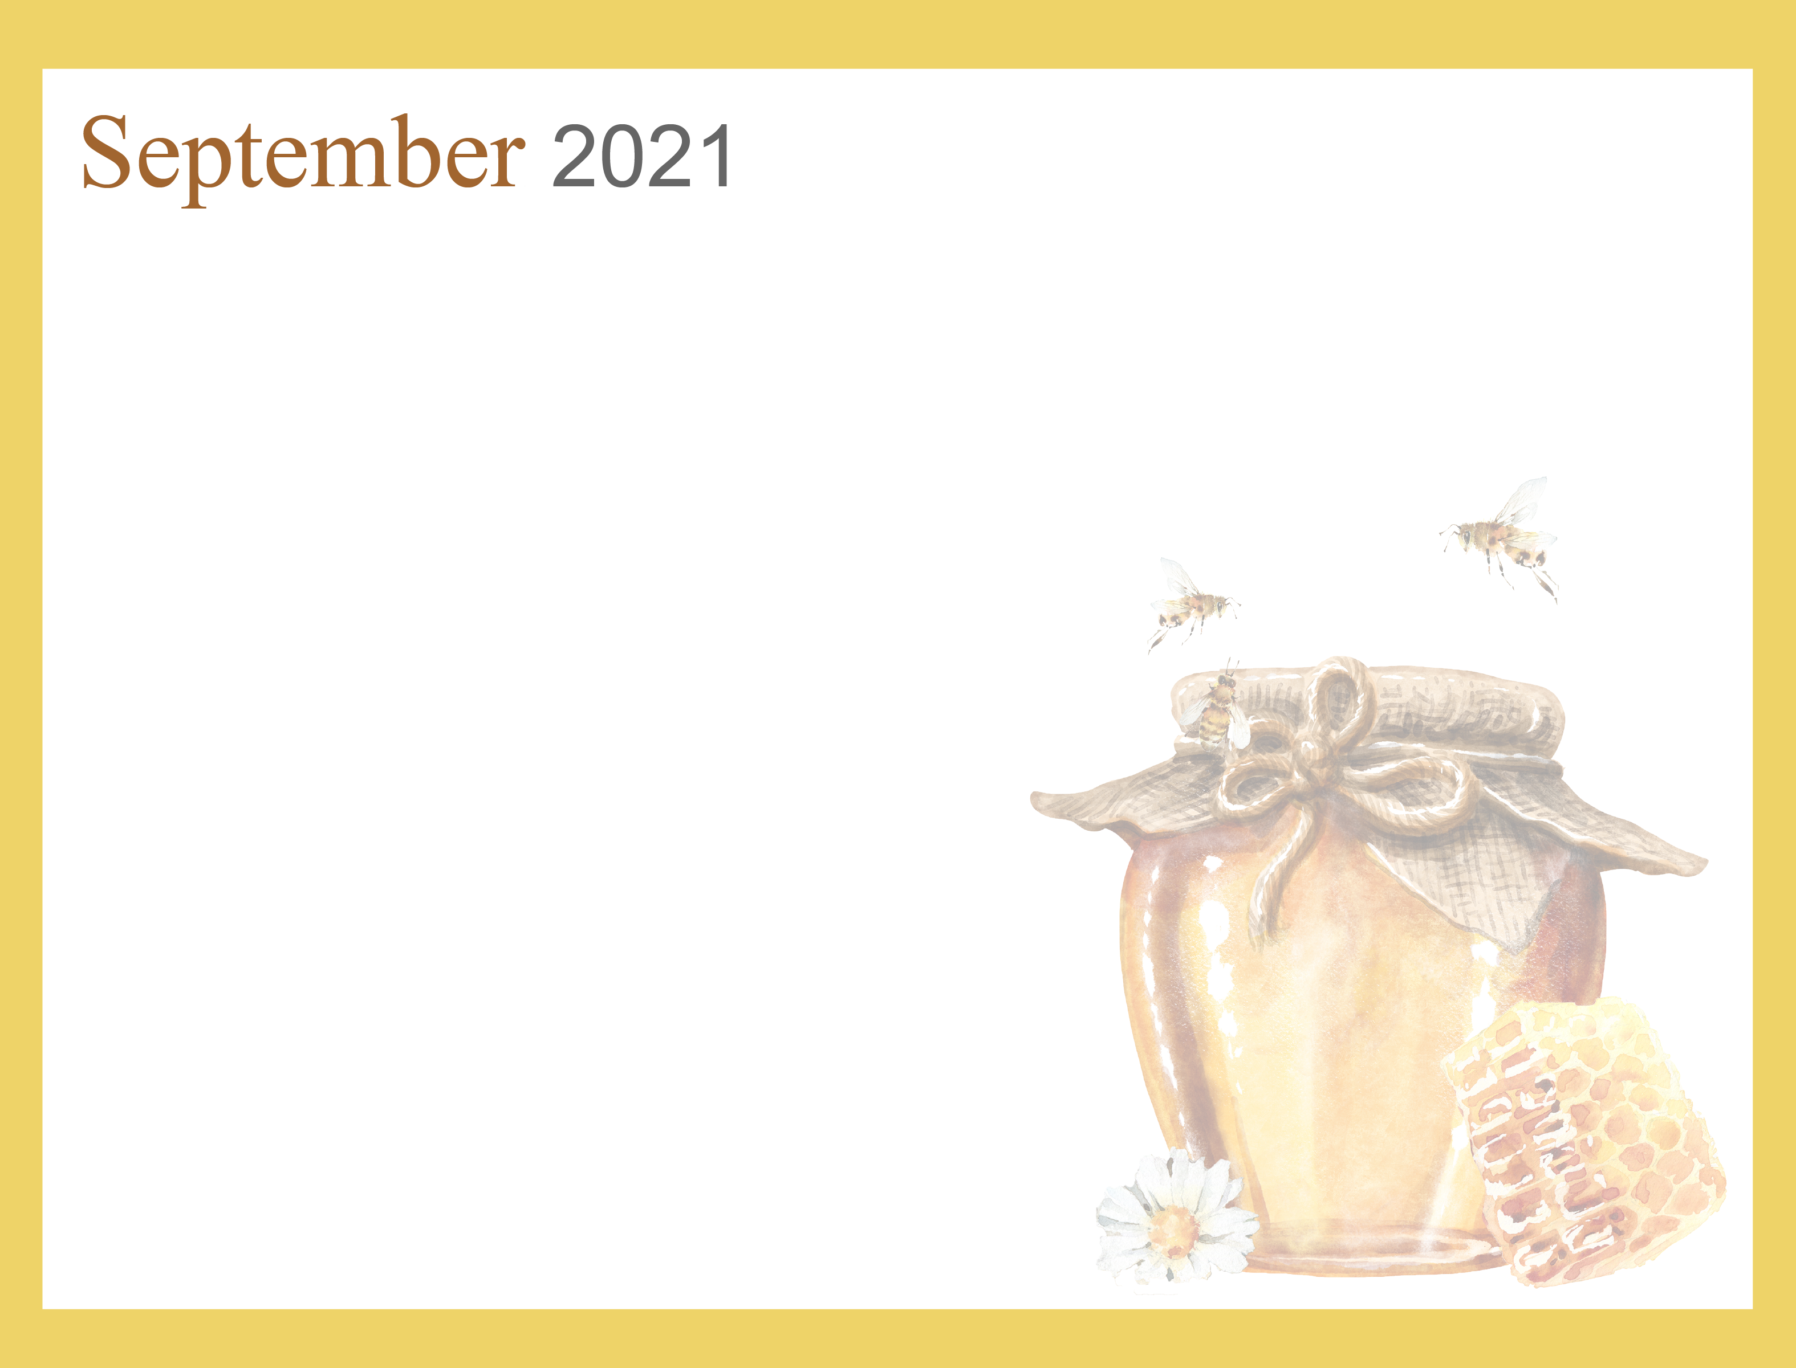
Noelle Nieuwenhuis, Recreation Therapist ext. 519-751-7096 nnieuwenhuis@sjltc.ca

