Sunday | Monday | Tuesday | Wednesday |  | Thursday | Friday | Saturday
 |  |  |  |  | 1 | 2 | 3
4 | 5  Labor Day | 6 |  | 7 | 8 | 9 | 10
11  Grandparents Day | 12 | 13 |  | 14 | 15 | 16 | 17  Oktoberfest Begins
18 | 19 | 20 |  | 21 | 22  Autumn Begins | 23 | 24
25  Rosh Hashanah Begins | 26 | 27 |  | 28 | 29 | 30

  Level 3 Calendar |  |  |  | 10:30 Beauty Boutique – CP  1:45 Prize Bingo – CP  2:30 Sing Along – CP  6:30 Ring Toss – CP | 9:45 Exercise – CP  10:30 Exercise – PT  10:30 Resident Council Meeting – M  1:30 Mocktail Club with John Moorhouse – M  3:15 One to One’s | 1:30 Hoops  Game – CP
9:45 Church Service with  Gary Crosbie – M  2:30 Sing Along DVD – CP |  | 9:45 Hymn Sing  – PT  10:30 Hymn Sing  – CP  1:45 Left Right Center – CR  3:15 One to One’s | 9:45 September Word Twist – CR  10:30 Hangman – CR  1:45 Back to School Spelling Bee – M  3:15 Hand Massages  5:45 Ring Toss – PT | 9:45 Beauty Boutique – PT  10:30 Beauty Boutique – CP  1:45 Welcome September Adult Colouring – CR  3:15 iPad Fun | 9:45 Exercise  – CP  10:30 Exercise – PT  1:30 Mocktail Club with Jim Young – M  3:15 One to One’s  6:30 Tablebowling – CR | 10:45 Horseshoes – CR
9:45 Church Service with  Bryan McKee – M  3:30 Grandparent Stories & Discussions | 9:45 Exercise  – CP  10:30 Exercise – PT  1:30 Prize Bingo – M  3:15 Short Stories | 9:45 Online Nondenominational Church Service – CR  12:00 Resident BBQ Lunch – Sign up with Recreation Staff  2:00 Snakes & Ladders – CR  3:15 One to One’s | 9:30 One to One Visits  10:30 Catholic Mass – M  1:45 Men’s Group – M  1:45 True or False? – CR  3:15 Hand Massages  5:45 Swatterball – CR | 9:30 Beauty Boutique – CP  10:30 Drum Fit – M  1:30 Birthday Party with Don Dunham  – M  3:00 Beauty Boutique – PT | 9:45 Exercise – CP  10:30 Exercise – PT  1:30 Oktoberfest Mocktail Club with Dave Souliere – M  3:15 One to One’s | 9:45 Finish the Phrase – CR  3:30 Dice Roll – CR
9:45 Church Service with  Rev. Larry Amiro  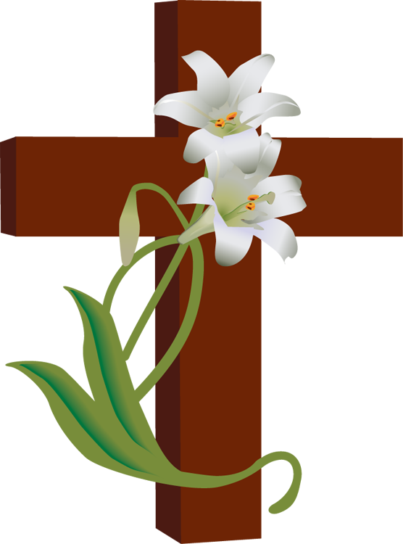  – M | 9:45 Exercise  – CP  10:30 Exercise – PT  1:30 Movie Afternoon – M  3:15 Short Stories | 9:45 Hymn Sing – PT  10:30 Hymn Sing – CP  1:30 Tim Hortons Drive! – Sign Up with Recreation Staff  3:15 One to One’s  6:30 Active Game – CR | 9:45 Trivia  Morning – CR  10:30 L3 Recreation Meeting – CR  1:45 Food Committee Meeting – M  1:45 Arts n’ Crafts – CR  3:15 Hand Massages | 9:45 Beauty Boutique – PT  10:30 Beauty Boutique – CP  1:45 Prize Bingo – CR  3:15 iPad Fun | 9:45 Exercise – CP  10:30 Exercise – PT  1:30 Welcome Fall Mocktail Club with Jeff Dawdy – M  3:15 One to One’s  5:45 Shuffleboard – CR | 
9:45 Church Service with  Bryan McKee – M  1:30 Yahtzee – CR | 9:45 Exercise  – CP  10:30 Exercise – PT  1:30 Surprise Bingo – M  3:15 Short Stories | 9:45 Online Nondenominational Church Service – CR  11:00 Garden Visits  1:45 Obie Cart Games – CR  3:15 One to One’s | 9:30 One to One Visits  10:30 Catholic Mass – M  1:45 Men’s Group – M  1:45 Name that Golden Oldie – CR  3:15 Hand Massages  6:30 Q Ball Toss – CR | 9:30 One to  One Visits  10:30 Drum Fit – M  1:45 Roll & Bowl – CR  3:15 iPad Fun | 9:45 Exercise – CP  10:30 Exercise – PT  1:30 Mocktail Club with the Clements – M  3:15 One to One’s  5:45 Horse Races – CR | CP = Canary Path  PT = Pine Trail  CR = Common Room  M = McMillen  Hall
Noelle Nieuwenhuis, Recreation Therapist 519-751-7096 ext. 3048 nnieuwenhuis@sjltc.ca

