Sunday | Monday | Tuesday | Wednesday |  | Thursday | Friday | Saturday
 |  |  |  | 1 | 2 | 3 | 4
5 | 6  Labor Day  Rosh Hashanah Begins | 7 |  | 8 | 9 | 10 | 11
12  Grandparents Day | 13 | 14 |  | 15  Yom Kippur Begins | 16 | 17 | 18  Oktoberfest Begins
19 | 20  Sukkot Begins | 21 |  | 22  Autumn Begins | 23 | 24 | 25
26 | 27 | 28  Simchat Torah Begins |  | 29 | 30

  Level 3 Calendar |  |  | 9:30 Beauty  Boutique – CP  10:30 Beauty Boutique – PT  1:45 Horse Races - CP  3:15 Hand Massages – PT | 9:45 Morning  Worst Twist – CR  10:30 Trivia - CR  1:45 Prize Bingo - CP  3:15 Short Stories – PT  6:30 Ring Toss – CP | 9:45 Exercises –  CP  10:30 Exercises – PT  10:30 Resident’s Council Meeting – M  1:30 Mocktail Club with the Clements – M  3:15 One to One’s – T | 10:30 Music and Movement – PT  2:30 Tablebowling - CP
9:45 Church Service with Gary Crosbie – M  2:30 Lawn Darts - CR | 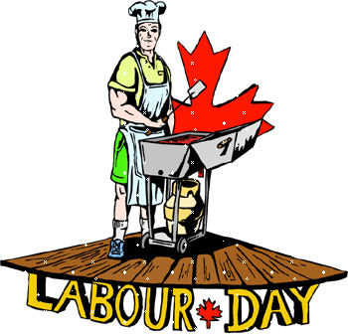 | 9:30 Hymns – CP  10:30 Hymns – PT  1:45 Snakes & Ladders – CR  3:00 Tuck Shop  Cart – T  5:45 Hoops Game – CR | 9:30 Beauty Boutique – T  10:30 Catholic Mass – M  1:45 Left Right Center – CP  3:15 Hand Massages – PT | 9:45 Finish the Phrase – CR  10:30 iPad Fun – T  1:45 Prize Bingo – CP  3:15 Short Stories – PT  5:45 Trivia Night – CR | 9:45 Exercises –  CP  10:30 Exercises – PT  1:30 Mocktail Club with Dave Shakespeare - M  3:15 One to One’s – T | 9:30 Board Games – CP  1:30 Music and Movement – PT  3:30 Sing Along - CR
9:30 Sunday Morning Hymns – CR  1:30 Swatterball – CP  3:30 Ball Toss – PT | 9:45 Exercises –  CP  10:30 Exercises – PT  1:45 Bingo – M  3:15 Short Stories – T | 9:30 Hymns – CP  10:30 Hymns – PT  1:45 Trivia Afternoon – CR  3:00 Tuck Shop  Cart – T  6:30 Active Game - CR | 9:30 Beauty Boutique – CP  10:30 Beauty Boutique – PT  1:45 Shuffleboard - CR  3:15 Hand Massages | 9:45 Dice Roll - CR  10:30 iPad Games –T  1:30 Birthday Party with Dave Shakespeare – M  3:15 Short Stories – PT  5:45 Darts - CR | 9:45 Exercises –  CP  10:30 Exercises – PT  1:30 Mocktail Club with Jack Coulson – M  3:15 One to One’s – T | 10:30 Hangman – CP  2:30 Swatterball – PT
10:30 Sunday Morning Hymns – CR  2:30 Finish the Phrase – CR | 9:45 Exercises –  CP  10:30 Exercises – PT  1:30 Food Committee – M  1:45 September Word Twist – CP  3:15 Short Stories-PT | 9:30 Hymns – CP  10:30 Hymns – PT  1:45 Tablebowling - CR  3:00 Tuck Shop  Cart – T  6:30 Ring Toss – CR | 9:30 Beauty Boutique – T  10:30 Catholic Mass – M  12:00 L3 BBQ – hummingbird court  1:30 Welcome Fall with Jeff Dawdy – M | 9:45 Sing Along  DVD - CP  10:30 Sing Along DVD - PT  1:45 Prize Bingo - CP  3:15 Short Stories – PT  6:30 Trivia Night – CR | 9:45 Exercises –  CP  10:30 Exercises – PT  1:45 Travelling Ice Cream Cart – T  3:15 One to One’s - T | 9:30 Swatterball – CR  1:30 Roll the Dice – CP  3:30 Roll the Dice – PT
9:45 Church Service with Brian McKee - M  1:30 Horse Shoes – CR | 9:45 Exercises –  CP  10:30 Exercises – PT  1:45 Bingo – M  3:15 Short Stories – T | 9:30 Hymns – CP  10:30 Hymns – PT  1:45 Adult Colouring – CR  3:00 Tuck Shop  Cart – T  5:45 Swatterball – CR | 9:30 Beauty Boutique – CP  10:30 Beauty Boutique – PT  1:45 Trivia Afternoon – CR  3:15 Hand Massages | 9:45 October Word Scramble – CR  10:30 Finish the Phrase – CR  1:45 Prize Bingo - CP  3:15 Short Stories – PT  5:45 Music and Movement – CR |   CP = Canary Path  PT = Pine Trail    CR = L3 Common Room  M = McMillen Hall  T= Travelling  Please see daily white sheets for any changes
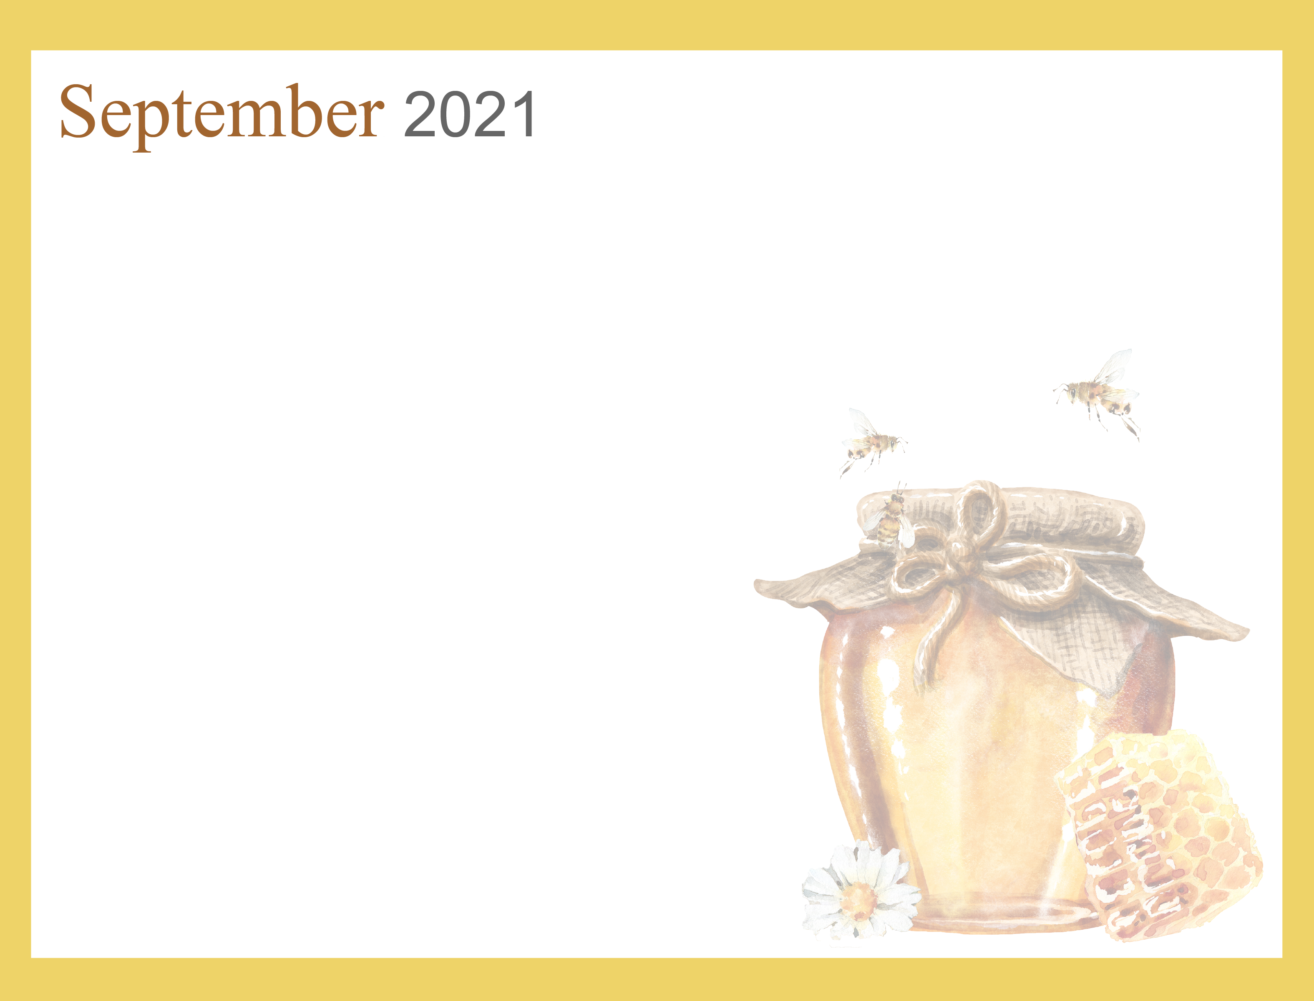
Noelle Nieuwenhuis, Recreation Therapist ext. 519-751-7096 nnieuwenhuis@sjltc.ca

