Sunday | Monday | Tuesday | Wednesday | Thursday | Friday | Saturday
1

New Year’s Day
2 | 3 | 4 | 5 | 6 | 7 | 8
9 | 10 | 11 | 12 | 13 | 14 | 15
16 | 17  Martin Luther King Jr. Day | 18 | 19 | 20 | 21 | 22
23  Activity Professionals Week | 24 | 25 | 26  Australia Day (observed) | 27 | 28 | 29
30 | 31

Lilac Calendar |  |  |  |  |  | 
10:45 Hymn Sing  2:30 Shuffleboard   | 9:45 Exercise  10:30 Hand Massages  1:45 Coffee & News  2:30 Busy Hands  3:30 One to One Visits | 9:45 Beauty Boutique  10:30 From Aardvark to Zebra  1:45 Crafting Corner  3:30 Beach Ball Toss | 9:45 Bowling  10:30 Word Twist  1:45 Ladies Tea  3:30 Walks & Talks | 9:45 Hymn Sing  10:30 Horse Shoes  1:45 Sensory Bingo  2:30 Wheel of Fortune  3:30 iPad Fun  6:30 Swatterball | 9:45 Exercise  10:30 Current Events  1:45 Travelling Coffee & Treats 3:30 Short Stories | 9:45 Busy Hands  1:30 Singalong DVD  3:30 Hoops
9:45 Hymn Sing  1:30 Music & Movement  3:30 Word Twist | Take Down Decorations Day   | 9:45 Beauty Boutique  10:30 Sensory Visits  1:45 Crafting Corner  3:30 Short Stories  6:30 Lawn Darts | 9:45 Trivia Morning  10:30 Funnel Ball  1:45 Spiritual Activity  2:30 Dice Roll  3:30 Hand Massages | 9:45 Hymn Sing  10:30 Hangman  1:45 Hoops  2:30 Men’s Group  3:30 iPad Fun  6:30 Shake Loose a Memory | 9:45 Exercise  10:30 Current Events  10:30 Resident Council Meeting  1:45 Drumming  1:45 Travelling Tea Party  2:30 Reminiscing  3:30 Walks & Talks | 10:45 Short Stories  2:30 Parachute
10:45 Hymn Sing  2:30 Bowling   | 9:45 Exercise  10:30 Hand Massages  1:45 Coffee & News  2:30 Junk Drawer Detective  3:30 One to One Visits | 9:45 Beauty Boutique  10:30 Ball Toss  1:45 Painting  3:30 Short Stories  6:30 Funnel Ball | 9:45 Current Events  10:30 Laundry Helpers  3:30 Music & Movement | 9:45 Hymn Sing  10:30 Shuffleboard  1:45 Dice/Card Bingo  2:30 Movie & Treats  5:45 Games Afternoon | 9:45 Exercise  10:30 Name That Tune  1:45 Charcuterie Cart  3:30 Puzzles & Games | 9:45 Trivia Morning  1:30 Drumming  3:30 Walks & Talks
9:45 Hymn Sing  1:30 Swatterball  3:30 Left, Right Centre | 9:45 Exercise  10:30 Hand Massages  1:45 Coffee & News  2:30 Word Joggers    3:30 One to One Visits | 9:45 Beauty Boutique  10:30 Swatterball  1:45 Crafting Corner  3:30 Short Stories  5:45 Horse Races | 9:45 Trivia Morning  10:30 Swatterball  1:45 Spiritual Activity  2:30 Snakes & Ladders  3:30 Walks & Talks | 9:45 Hymn Sing  10:30 Word Game  1:45 Lawn Darts  2:30 Baking  5:45 Games & Puzzles | 9:45 Exercise  10:30 Travelogue  1:45 Busy Hands  1:45 Travelling Popcorn Cart  3:30 One to One Visits | 10:45 Wheel of Fortune  2:30 Horseshoes  
10:45 Hymn Sing  2:30 Snakes & Ladders  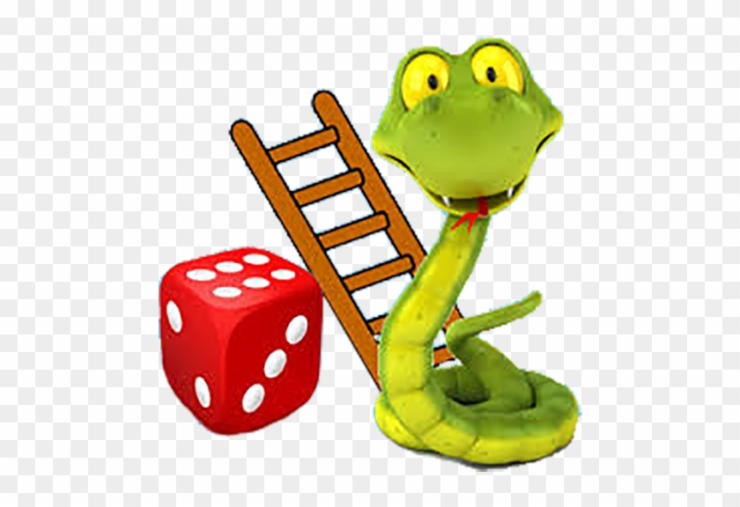 | 9:45 Exercise  10:30 Hand Massages  1:45 Coffee & News  2:30 Trivia  3:30 One to One Visits | .

Kristin McGaw, Recreation Therapist (519) 751-7096 ext. 2228, kmcgaw@sjltc.ca

