Sunday | Monday | Tuesday | Wednesday | Thursday | Friday | Saturday
 |  | 1 | 2 | 3 | 4 | 5
6 | 7 | 8 | 9 | 10  Hanukkah Begins | 11 | 12
13 | 14 | 15 | 16 | 17 | 18 | 19
20 | 21  Winter Begins | 22 | 23 | 24 | 25  Christmas | 26  Boxing Day (Canada)  Kwanzaa Begins
27 | 28 | 29 | 30 | 31  New Year’s Eve

 |  | 9:45 Exercise  1:45 Adult  Colouring  2:45 Word Games Cart  3:45 Current  Events  6:30 Tablebowling | 9:45 Beauty Boutique  1:45 Hand Massage  2:45 iPad Fun  3:45 Visits | 9:45 Exercise  1:45 Ball Toss  2:45 Eggnog Ice Cream Cart  3:45 Sorting | 9:45 Centerpiece Craft  1:45 Virtual  Visits  2:45 Roll a Snowman  3:45 Visits | 9:30 Sing Along DVD
2:30 Games Afternoon | 9:45 Hymn Sing  1:00 Short Stories  3:45 Visits | 9:45 Exercise  1:45 Christmas Card Making  2:45 Travelling Bracelet Making  3:45 Reading  6:30 Dart Toss | 9:45 Busy Bee  1:45 Egg Nog Cart  2:45 iPad Fun  3:45 Visits | 9:45 Exercise  1:45 Reading  2:45 Library Book Cart  3:45 Short Stories | 9:45 Beauty Boutique  1:45 Virtual Visits  2:45 Hot Chocolate Cart  3:45 Visits | 10:30 Christmas Sing Along DVD
3:30 Adult Colouring | 9:45 Hymn Sing  1:45 Card Making  2:45 Snowball Cart Craft  3:45 Visits | 9:45 Exercise  1:45 Adult Colouring  2:45 Activity  Cart  3:45 Reminiscing  6:30 Hoops Game | 9:45 Beauty Cart  1:45 Stories  2:45 iPad Fun  3:45 Visits | 9:45 Exercise  1:45 Poinsettia Craft Cart  3:45 Snoezelen | 9:45 Horse Shoes  1:45 Virtual Visits  2:45 Travelling Christmas Trivia  3:45 Visits | 1:30 Christmas Sing Along DVD
9:30 Music and Movement | 9:45 Hymn Sing  1:45 Christmas Carols  2:45 Beauty Cart  3:45 Visits | 9:45 Exercise  1:45 True &  False  2:45 Cookie  Cart  3:45 Snoezelen  6:30 Tablebowling | 9:45 Painting Morning  1:45 Christmas Social Walkabout | 10:45 Exercise  2:45 Travelling Christmas Eve Activities | Christmas  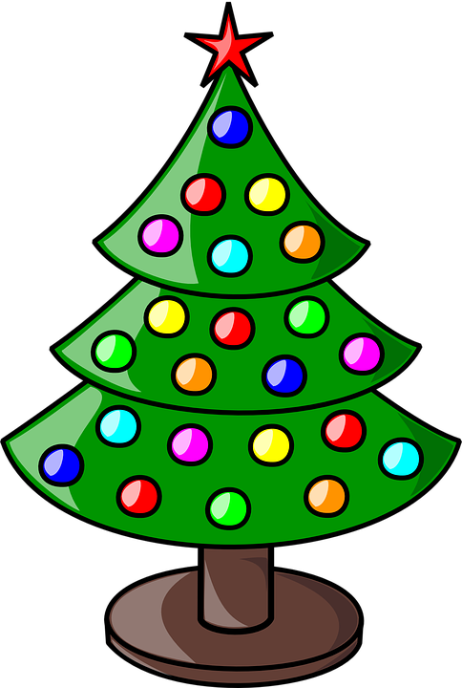  Day! | Boxing  Day
10:30 Swatterball | 9:45 Hymn Sing  1:45 Short Stories  2:45 Games  3:45 Visits | 9:45 Exercise  1:45 Short Stories  2:45 Beauty Boutique Cart  3:45 Just for Laughs  6:30 Shuffleboard | 9:45 Masquerade Mask Cart  1:45 Sing Along  2:45 iPad Fun  3:45 Visits | 9:45 Exercise  1:45 New Year’s Resolutions  2:45 New Year’s Bubbly Cart  3:45 Reminisce 2020 | Bluebird  Calendar  
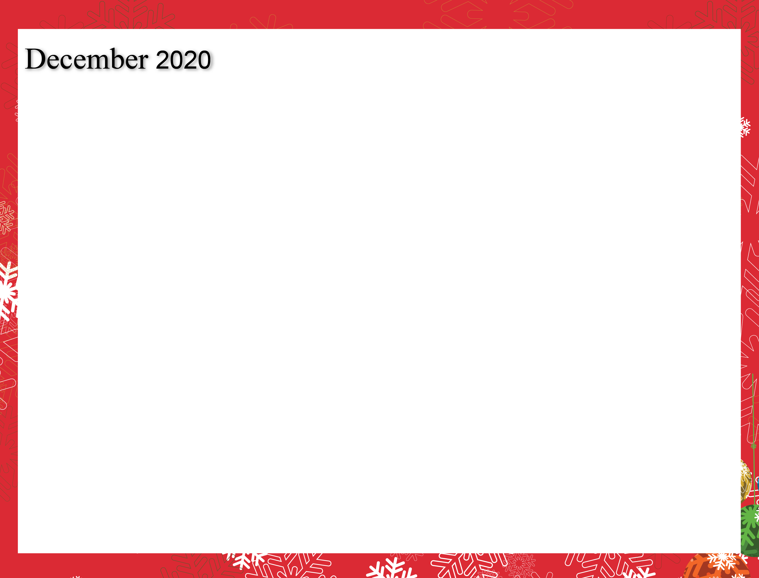
Noelle Nieuwenhuis, Recreation Therapist, 519-751-7096 ext. 3048 nnieuwenhuis@sjltc.ca

