Sunday | Monday | Tuesday | Wednesday |  | Thursday | Friday | Saturday
 |  |  |  |  | 1  All Fools’ Day | 2  Good Friday | 3
4  Easter Sunday | 5 | 6 |  | 7 | 8 | 9 | 10
11 | 12  Ramadan Begins | 13 |  | 14 | 15 | 16 | 17
18 | 19 | 20 |  | 21 | 22  Earth Day | 23 | 24
25 | 26 | 27 |  | 28 | 29 | 30  Arbor Day

Bluebird Calendar |  |  |  | 9:45 One to One Exercise  10:30 Trivia & Easter Treats  1:45 Beauty Boutique  2:30 Easter Craft  3:30 Adult Colouring | Good Friday    No Programming | 1:30 Dice Roll
Easter Bunny Surprises!  9:30 Easter Trivia |   Happy Easter! | 9:45 One to One Exercise  10:30 iPad  Fun  1:45 “Crazy for Caramels Day”-Caramel Treat Cart  3:30 Outdoor Visit | 9:45 Coffee & Current Events  10:30 Balloon Badminton  1:45 Bird Feeder Craft  2:45 Travelling Tuck  3:30 Walk & Talks | 9:45 One to One Exercise  10:30 Spiritual Activity  1:45 Beauty Boutique  2:30 Get Gardening  3:30 Pair Up | 9:45 Tea & Trivia  10:30 Dice Roll  1:45 April Ice Cream Cart  2:30 Ball Toss  3:30 Hand Massages | 2:30 Painting
10:30 YouTube Fun | 9:45 Hymn Sing  10:30 Curls & Up Do’s  1:45 Grilled Cheese Treat  2:30 Small Group Bowling  3:30 Reminiscing | 9:45 Small Group Exercise  10:30 Picture a Word  1:45 Active Games  3:30 Travelling Tuck Shop | 9:45 Coffee & Current Events  10:30 Walks & Talks  1:45 Get  Gardening  3:30 Comedy Afternoon | 9:45 Small Group Exercise  10:30 What Am I?  1:45 Beauty Boutique  2:30 Men’s Program  3:30 One to One Visits | 9:45 Mini Putt  10:30 Missing Last Letters  1:45 Popcorn Tasting  3:30 Outdoor Visits | 3:30 Short Stories
1:30 Swatterball | 9:45 Hymn Sing  10:30 Hangman  1:45 Ladies  Tea  2:30 Small Group Bingo  3:30 Washer Toss | 9:45 Small Group Exercise  10:30 What’s in the Bag  1:45 Small Group Bingo  3:30 Travelling Tuck Shop | 9:45 Coffee & Current Events  1:45 Get Gardening  3:30 Cookie Decorating | 9:45 Small Group Exercise  1:45 Beauty Boutique  3:30 Outdoor Walks | 10:30 Ring Toss  2:45 Spring Fling Dance  3:30 Hand Massages | 9:30 Adult Colouring
2:30 Puzzles and Board Games | 9:45 Hymn Sing  10:30 Laundry Folding  1:45 Tea and Trivia  2:30 Cookie Decorating  3:30 Walks &  Talks | 9:45 Small  Group Exercise  10:30 Reminiscing  1:45 Dice Roll  2:30 Ball Toss  3:30 Travelling Tuck Shop | 9:45 Coffee & Current Events  2:45 Crafters Corner  3:30 Swatterball | 10:30 Small Group Exercise  2:30 Beauty Boutique  2:30 One to One Visits | 10:30 Curls & Up Do’s  1:45 Treat Cart Afternoon  2:30 Jazz Party | 
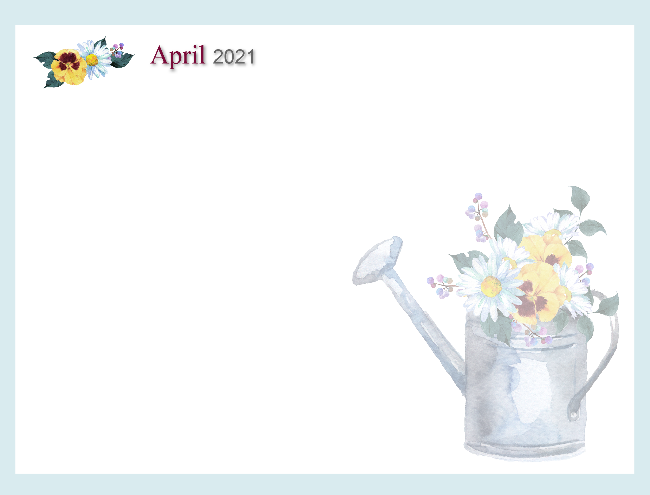
Noelle Nieuwenhuis, Recreation Therapist 519-751-7096 ext. 3048 nnieuwenhuis@sjltc.ca

