Sunday | Monday | Tuesday | Wednesday |  | Thursday | Friday | Saturday
 |  |  |  |  | 1  All Fools’ Day | 2  Good Friday | 3
4  Easter Sunday | 5 | 6 |  | 7 | 8 | 9 | 10
11 | 12  Ramadan Begins | 13 |  | 14 | 15 | 16 | 17
18 | 19 | 20 |  | 21 | 22  Earth Day | 23 | 24
25 | 26 | 27 |  | 28 | 29 | 30  Arbor Day

Ground Calendar |  |  |  | 10:00 Virtual family visits and one to one’s  11:15 April fools’ day activities  2:00 Maundy Thursday trivia | Good Friday | 9:30 Easter Trivia
2:30 Fellowship | Easter Monday | 9:45 Travelling games  10:30 Armchair traveler  1:45 Virtual family visits and one to one’s | 10:00 Sensory Stim  1:30 Travelling Table games  2:30 Crafts (RtoR) | 10:00 Virtual family visits and one to one’s  2:00 Funny Videos (RtoR)  5:45 Hangman (RtoR) | 9:45 Exercises  10:30 Resident Council Meeting (L2 CR)  2:00 Travelling Trivia | 10:30 Sing along
3:30 Hymn Sing | 9:45 Exercises  10:30 Cards  2:00 Current Events | 9:45 Travelling games  10:30 Name that tune  1:45 Virtual family visits and one to one’s | 10:00 Sensory Stim  1:30 Current Events  2:30 Busy Hands | 10:00 Virtual family visits and one to one’s  2:00 Horticulture  6:30 Sing along | 9:45 Exercises  10:30 Ipad Fun  2:00 Travelling word games | 1:30 Adult coloring
9:30 Fellowship | 9:45 Exercises  10:30 Hand massages  2:00 Current Events | 9:45 Travelling games  10:30 Armchair traveler  1:45 Virtual family visits and one to one’s | 10:00 Sensory Stim  1:30 Travelling table games  2:30 Move and meditate | 10:00 Virtual family visits and one to one’s  2:00 Prize Bingo (dining room) | 9:45 Exercises  10:30 Ipad Fun  2:00 Dog and cat Trivia | 2:30 Sing along
10:30 Hymn Sing | 9:45 Exercises  10:30 April showers trivia  2:00 Current Events | 9:45 Travelling games  10:30 Reminisce  1:45 Virtual family visits and one to one’s | 10:00 Sensory Stim  1:30 Currents events  2:30 Busy Hands | 10:00 Virtual family visits and one to one’s  2:00 Horticulture | 9:45 Exercises  10:30 Ipad Fun  2:00 Travelling word games | 3:30 Wheel of fortune
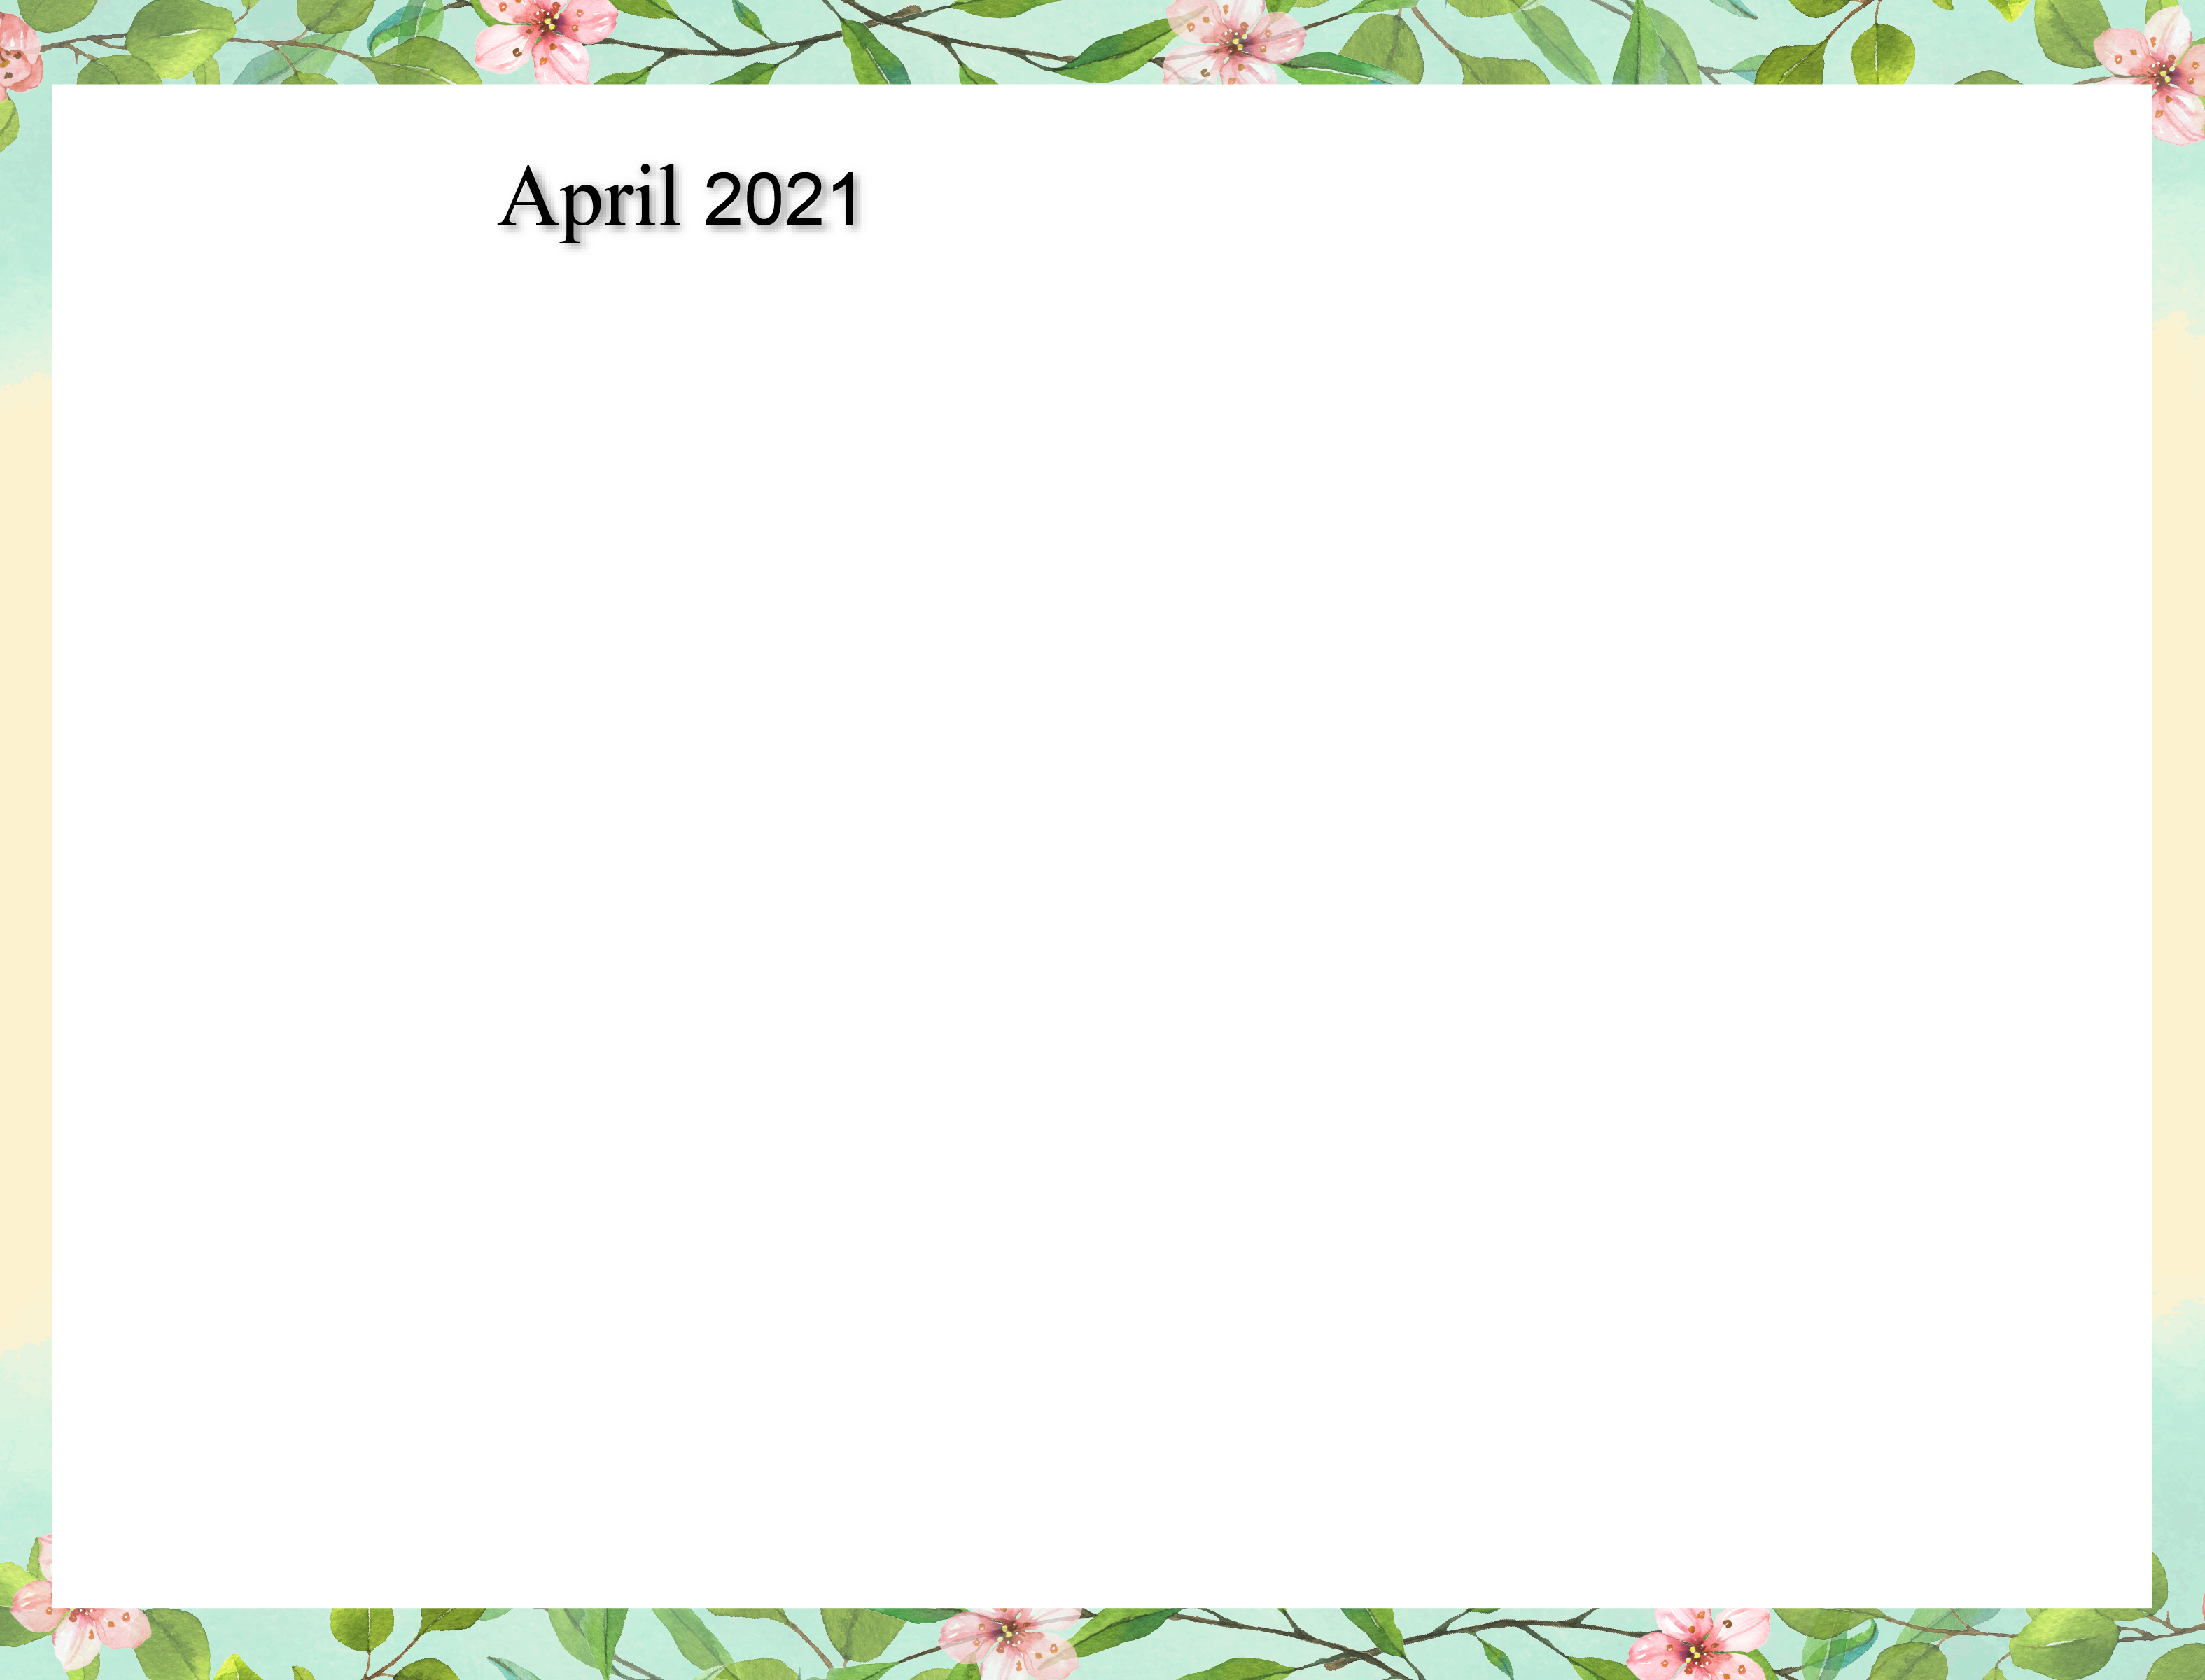
(RtoR)=Room to Room and travelling programs

